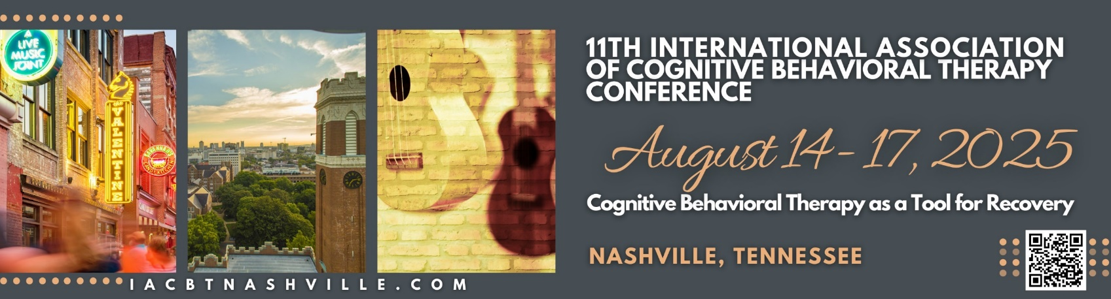
Dear Colleagues,
On behalf of the organizing committee of the 11th International Association of the Cognitive Behavioral Therapy (CBT) Conference, we are excited to invite you to our first North American site, and first in-person event since 2017!
We are eager to reconvene this engaging and passionate conference for the first time since the pandemic in the heart of Music City in downtown, Nashville Tennessee, United States of America on August 14 – 17, 2025. As such, the Committee is diligently working to develop challenging and engaging scientific program designed to expand our minds, kindle new collaborations and foster cross-research conversations.
The theme of the Congress is CBT as a Tool for Recovery. We will emphasize that embracing evidence-based, high-fidelity CBT is a systematic approach for achieving durable recovery. In his 1976 book, Cognitive Therapy of the Emotional Disorders, the late Tim Beck wrote that cognitive therapy acts by “helping the patient draw on his own problem-solving apparatus.,” and prioritized the individual’s own view of their life. Until the end of his life, Tim Beck focused on extending the concept of recovery to as many people as possible.
Almost five decades later, CBT researchers have refined interventions to relieve distress and enable people to move forward in life. Many times, Tim marveled at the number of new problems he found CBT helping. The continued improvements in treatments allow CBT providers to achieve a higher level of partnership with their individuals so they may live the life they desire.
Please join the expected 800 or more colleagues to learn and enhance the CBT field. Registration will open on November 11th, 2024 at https://iacbt.societyconference.com/v2/.
We look forward to seeing you in 2025 in Nashville, Tennessee – known for its electric downtown, music and entertainment, historical landmarks, and close access to nature!

Best Regards,

Aaron Brinen, PsyD
IACBT 2025 Conference Chair

